BG-4 BENCH STATEMENTS OF FACT
- A positive pressure leak could be caused by a leakage in or at device components.
- The battery in the Sentinel should be replaced every 6 months.
- Dow Corning 111 is to be used to lubricate O-rings.
- The pressure relief valve is designed to open when the pressure within the breathing circuit is between +20 and +50 millimeters (+2 mbar and +5 mbar) of pressure measured on the water gage.
- To prepare for testing adjust zero point of the RZ-25 tester.
- Test adapter is used to connect the BG-4 apparatus to the RZ-25 tester.
- A leaky exhalation or inhalation valve could be caused by a defective valve seat or valve disc.
- During the exhalation valve test, if valve is operating properly, -10 mbar is indicated on the pressure gauge.
- The EPDM breathing hoses use Bayonet Rings.
- During testing of the inhalation valve, if valve is operating properly, +10 mbar is indicated on the pressure gauge.
- During the positive pressure leak test, the pressure change within 1 minute must be lower than 1 mbar.
- Only DRAGERSORB 400 is to be used to fill the refillable cartridge.
- The factory packed cartridge is good for 4 years from the manufacture date.
- A positive pressure in the breathing circuit prevents ambient air from entering the system.
- The BG-4 is approved with a factory/refillable cartridge.
- The Sentinel monitoring system comprises a sensor unit, switchbox, and Sentinel.
- A steel cylinder is full at 3135 psi when a + is stamped at hydro test.
- The BG-4 constant dosage must be 1.5 to 1.9 L/min.
- The drain valve should not open at less than 10 mbar.
- A fully filled steel oxygen cylinder holds 440 liters of medical oxygen.
- The accuracy of the Sentinel pressure measurement is +or- 2% of the final value.

- Never replace the battery in potentially explosive areas.
- The weight of a fully charged BG-4 apparatus is 15kg (33 lbs.).
- Check the supply of oxygen gas on the Sentinel at intervals of approximately 15 minutes.
- During the constant dosage test, the breathing bag is inflated, the RZ-25 tester is set to red dosage, and the pressure relief valve is capped.
- During the constant dosage test, the needle of the RZ-25 tester should automatically settle between 1.5 and 1.9 LPM.
- The minimum valve provides greater than 80 L/min flow.
- The breathing bag has a 5.5 liter volume.
- Insert speech diaphragm, install retainer ring and tighten with spanner.
- The belt and harness must be dried prior to storage, to prevent growth of mold and fungus.
- The pressure reducer must be replaced every 6 years.
- Symbol X with error code indicates a failed self-check.
- The Sentinel pressure sensor converts pressure into digital signal.
- The cylinder connector and cylinder valve must not be contaminated with oil or grease.
- Three hexagon socket head screws are used in the battery cover of the Sentinel.
- Rubber parts must be particularly protected from direct exposure to radiation.
- Do not use any solvents, such as acetone, alcohol, benzene, white spirit, trichloroethylene, etc. for cleaning rubber and silicone parts.
- The first low pressure warning occurs when the pressure drops to approximately 700 psi.
- At the first low pressure warning approximately 75% of the oxygen has been used up.
- The last low pressure warning occurs when the pressure drops to approximately 145 psi.
- During the low pressure warning test, the alarm should activate at approximately 700 psi for a 4 hour apparatus.

- At the last low pressure warning approximately 95% of the oxygen has been used up.
- To start the main alarm, press the Yellow panic button in center of the Sentinel.
- When the first low pressure warning occurs, the alarm sounds intermittently for approximately 30 seconds and the red LED flashes constantly.
- When the last low pressure warning occurs, the alarm sounds intermittently without stopping and the red LED flashes constantly.
- Medium pressure in the BG-4 is between 58 psi and 64 psi.
- Medium pressure is delivered to the minimum valve.
- The drain valve opens at more than 10 mbar.
- The BG-4 breathing circuit is designed with an air cooler that can be filled with ice to reduce the temperature of the inhaled breath.
- Remove the Tally Key to activate the motion sensor.
- All parts which come in contact with the exhaled air must be thoroughly cleaned and disinfected after use.
- Disinfect parts by immersing them in a disinfectant bath using an approved disinfectant.
- Before washing the minimum valve, it is necessary to isolate the minimum valve with plug.
- Attach minimum valve to breathing bag so that the pin of the minimum valve and the mark on the breathing bag line up.
- All parts which have been disinfected should be rinsed thoroughly under running water.
- CO2 absorber is not approved for use after indicated expiration date.
- The maximum temperature of the air used to dry parts should not go above 60 degree C (140 degree F).

- Replace the high pressure O-ring located on the pressure reducer yearly for units which are in constant use.
- U.S. Department of Transportation requires hydro tests on composite cylinders every 5 years.
- Replace the O-ring at the plug-in coupling at least once every year for units which are in constant use.

- The inhalation/exhalation valve should be replaced every 3 years for units which are in constant use.
- The O-ring under the speech diaphragm should be lubricated with Dow Corning 111.
- The pressure reducer should be replaced after at least 6 years usage.
- A steel oxygen cylinder must be retested by a certified testing facility every 5 years.
- The BG-4 is approved for use at temperatures above -5 degree C (23 degree F)
- A defective pressure reducer should be replaced as needed.
- Only oxygen (medical grade or better) with > 99.5% purity is to be used to fill the BG-4 oxygen cylinders.
- The use of ice in the cooling system is only required at ambient temperature above 0 degree C (32 degree F).
- Pressurized oxygen in contact with oil, grease, or other contamination can result in fire or explosion.
- It is safe to use the BG 4 for up to 4 hours with a battery warning 1 Icon.
- The battery must be replaced if battery warning 2 Icon is indicated.
- A defective pressure reducer is the probable cause if the manual by-pass valve does not blow-off.
- The green LED flashes to indicate that the Sentinel is operating normally.
- Bypass output is > 50 L/min.
- Relief valve activation is 6 bar or (87 psi).
- The oxygen cylinder burst disc ruptures at 4,450 psi (307 bar).
- Refillable cartridge concerns are over packing and under packing.
- The FPS 7000 masks allow 90% peripheral vision.
- Polycarbonate or Plexiglas lenses can be used in the mask.
- A minimum of 2600 psi is needed for a Sentinel to perform a proper high pressure leak test.
- The drain valve opens at approximately 15 mbar and is therefore out of the RZ reading range.

- To prepare the ice pack:
Fill the ice receptacle with water up to 2 inches from rim Freeze at least 16 hours @ -15 degree C (5 degree F)
Fill to rim with water
Freeze again for another 8 hours

- If the speech diaphragm is deformed or shows signs of damage, it must be replaced.
- The BG-4 Sentinel lights up when the button is briefly pressed.
- Press then release the right hand button to display temperature.
- Do not re-use Factory cartridges.
- The breathing hoses are equipped with anti-crush rings.
- When conducting component checks use a test pressure between +7 mbar and +10 mbar with a max pressure loss of 1 mbar/min.
- Only the following batteries are approved for use in the Sentinel: Rayovac
Eveready
Panasonic
Ultra-life Lithium

BG-4
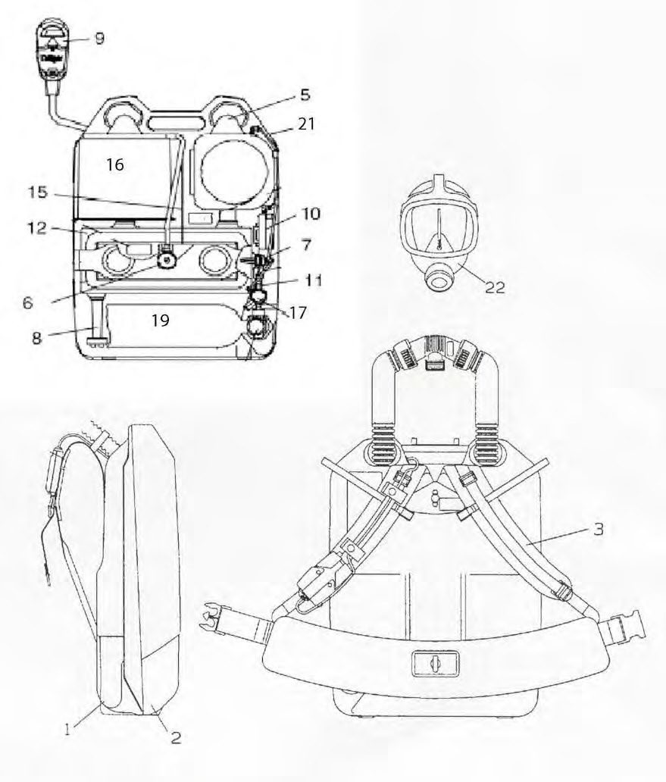

1 2  Cons. No. Designation | 1 2  Cons. No. Designation
- Carrying Housing  - Cover Shell, complete  - Shoulder Pad Assembly  - Cooler  - Relief valve, Complete  - Minimum Valve  - Drain Valve  - Sentinel  - Switch Box  - Pressure Sensor | 12 Breathing Bag  - Lever, Complete  - Factory/refillable cartridge  - Pressure Reducer BG4  19 Oxygen Cylinder  - Distribution Hose  - FPS 7000 Mask

Cover
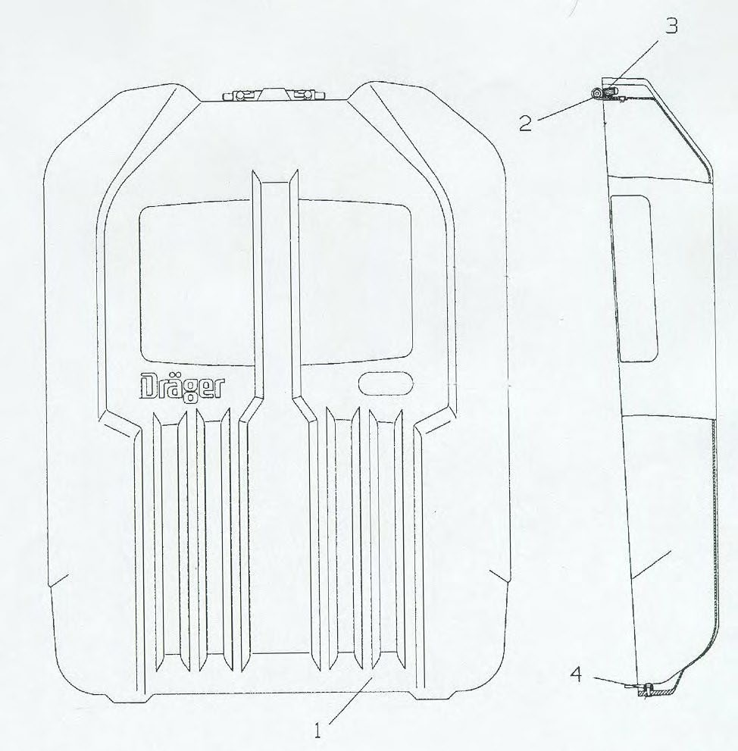

1  Cons. | No. | 2  Designation | 1  Cons. No. | 2  Designation
1  2 | Cover Shell Hinge |  | 3  4 | Grip Cap Button

Harness Assembly

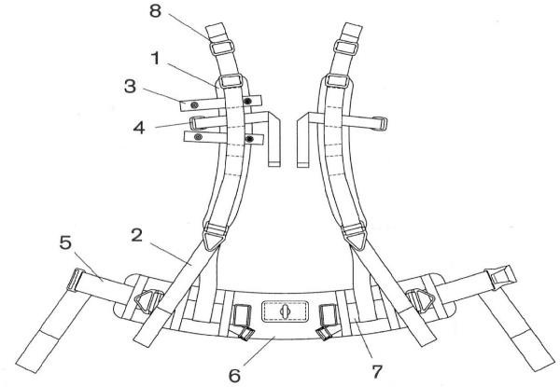

1  Cons. | No. | 2  Designation | 1  Cons. No. | 2  Designation
1 | Shoulder Pad Assembly |  | 5 | Adjusting Belt Assembly
2 | Shoulder Adjusting Strap |  | 6 | Waist belt
3 | Hose Clip |  | 7 | Belt Assembly
4 | Hose Strap Harness |  | 8 | Buckle

Breathing Hose Assembly

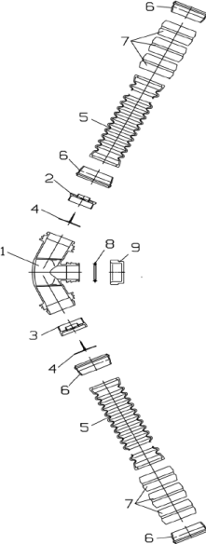

1  Cons. | No. | 2  Designation | 1  Cons. No. | 2  Designation
1 | Coupling |  | 6 | Bayonet Ring
2 | Inhalation Valve Seat |  | 7 | Anti-Crush rings
3 | Exhalation Valve Seat |  | 8 | Toroidal Sealing Ring
4 | Valve Disc |  | 9 | Sealing Cap
5 | Corrugated Hose

Cooling Canister (Revised Drawing)

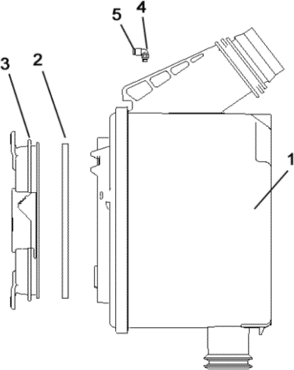

1  Cons. No. | 2  Designation | 1  Cons. No. | 2  Designation
1 | Cooler | 4 | Angle Connector
2 | O-Ring, Cooler | 5 | Reaction Ring
3 | Cover

Drain/Relief/Minimum Valve Assembly (Revised Drawing)

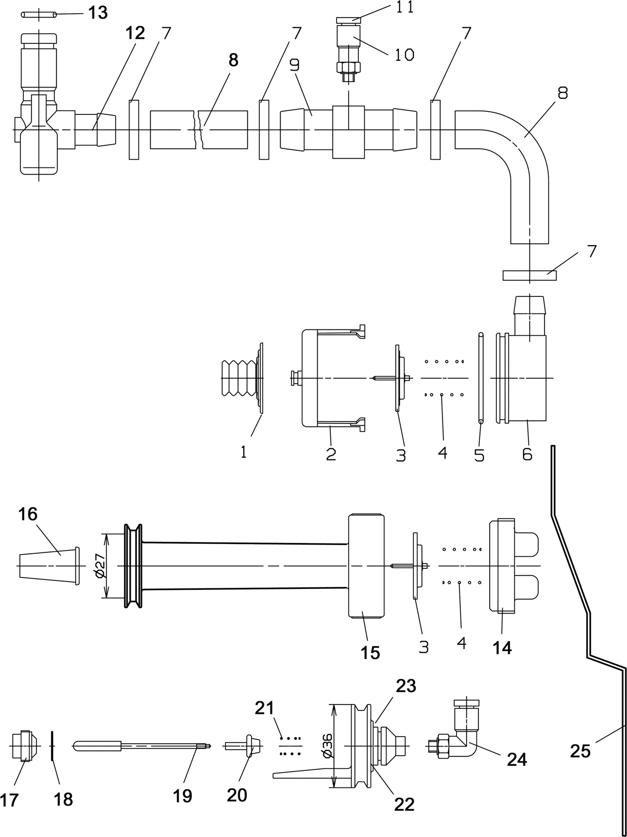

1 2  Cons. No. Designation | 1 2  Cons. No. Designation
- Valve Disc  - Crater Housing  - Valve Disc  - Spring  - O-Ring  - Cap  - Compression Ring  - Coupling  - O-Ring  14-16, 3-4 Drainage Valve | 14 Cap, Drain Valve  15-16 Drain Valve & Filter 17-24 Minimum Valve  - Crater  - Washer  19-20 Rocker Arm  21 Spring  - Angle Connector  - Holding Clamp

Sentinel
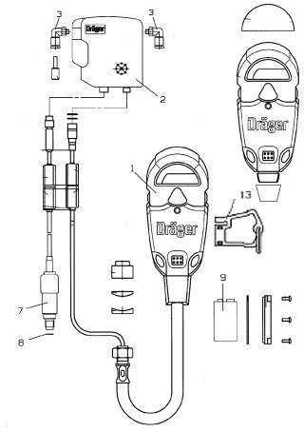

1  Cons. No. | 2  Designation | 1  Cons. No. | 2  Designation
1  2  3  7 | Sentinel Switch Box  Angle Connector Pressure Sensor | 8  9  13 | Copper Ring 9 volt battery Tally Key

Refillable Cartridge
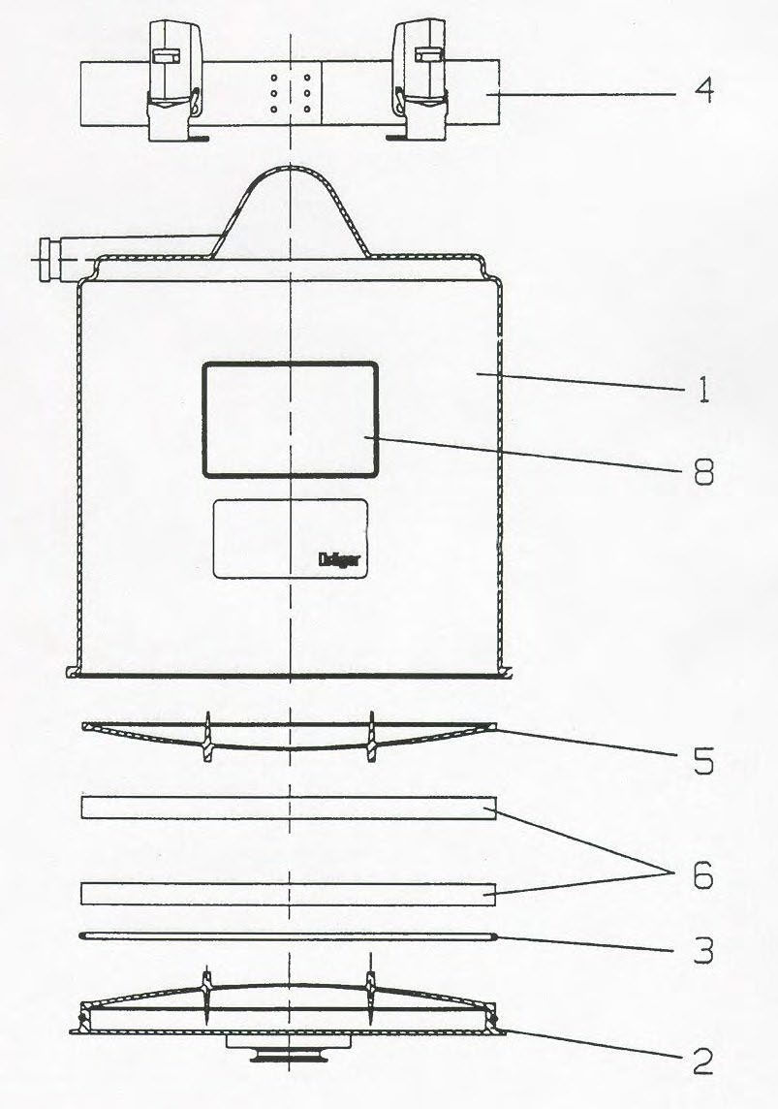

1 2  Cons. No. Designation | 1 2  Cons. No. Designation
- Refillable Cartridge  - Lid  - Seal, Refillable Cartridge  - Strap with Tension Spring Hook | - Refillable Scrubber Screen  - Filter Mats  8 NIOSH Approval Label

FPS 7000 Mask
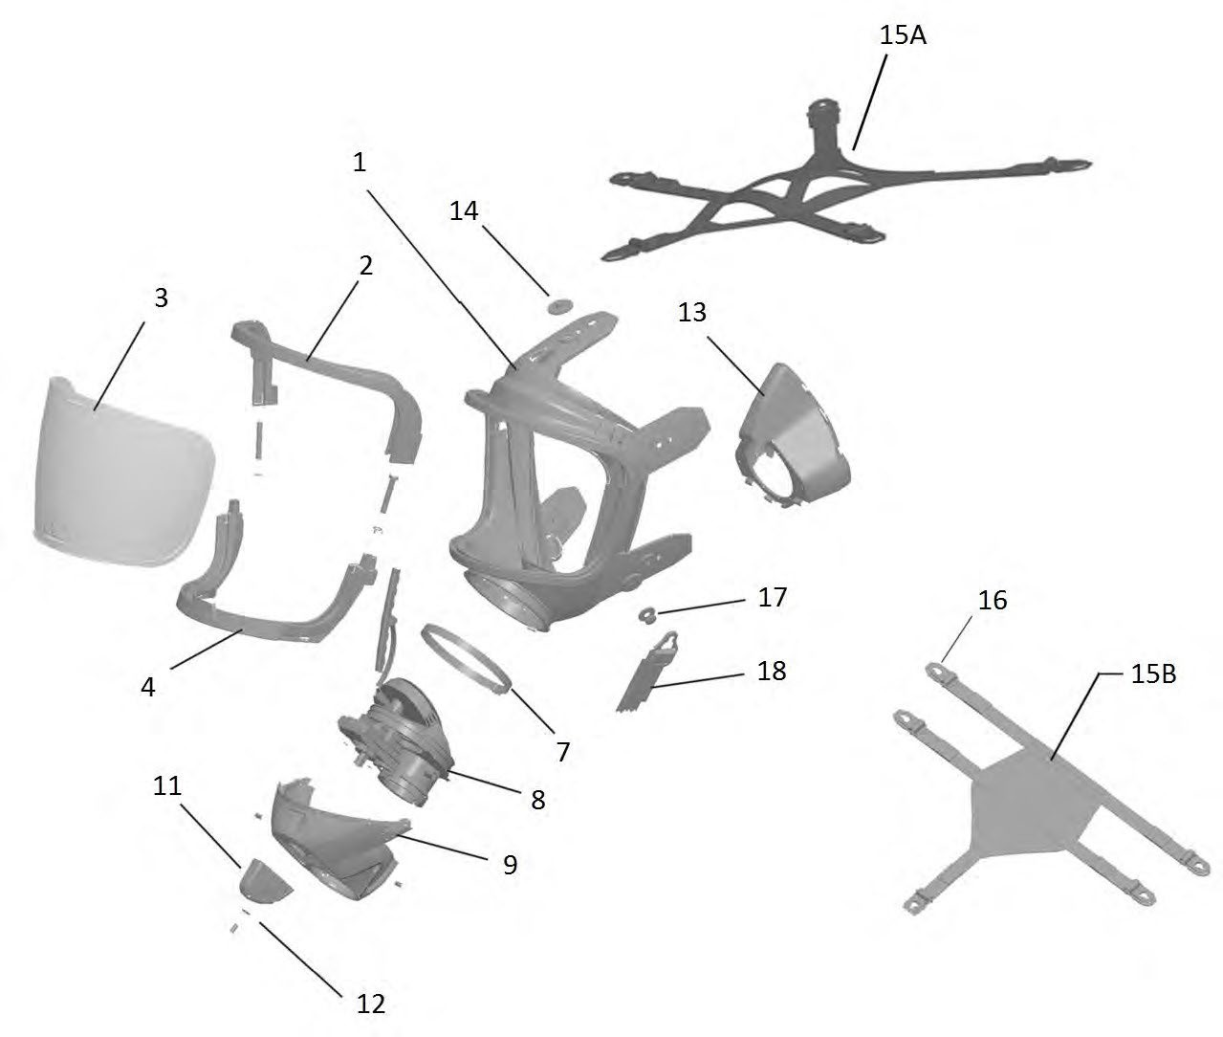

1 2  Cons. No. Designation | 1 2  Cons. No. Designation
- Mask Body FPS 7000  - Upper Visor Frame  - Visor  - Lower Visor Frame  - Clamp  - Connector Piece  - Cover  - Turning Knob  - Disc | - Inner Mask  - Button 15A Head Strap 15B Hairnet  - Sliding Buckle  - Double Button  - Neck Strap

